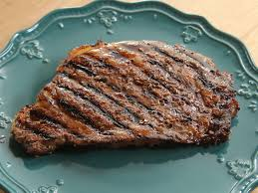

American Legion Steak fry

July 26th

6:00 – 8:00

Steak, Potato, Salad

And Dessert

$20 per person

Sign up at canteen